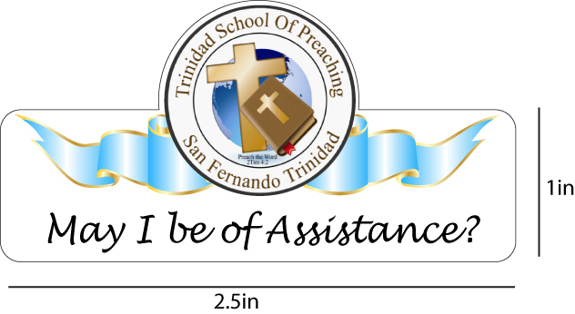
TRINIDAD SCHOOL OF PREACHING
SEPTEMBER REPORT
September started off with a bang! We aimed at a class of twenty and while we did not hit our target, we celebrate anyway. We now have a class of eleven. However, what was great is that we were able to get in first year four solid young men who have tremendous passion for ministry. Our student body is made up of eight males and three females. Given the challenges associated we are pleased to have this crop and anticipate great things.
Our schedule is as follows:
FIRST YEAR CLASS SECOND YEAR CLASS
1ST SEMESTER | TEACH
OT HIST 1 | GN
SYN GOSP | JC
RESEARCH Methods | DDS
Christian Dev. | MP
Christian Education | DDS
JOB | AG/KM
PSALMS | AP
Christian Dev | MP

The Christian Education course is an addition and focuses on concepts that will help the students design and deliver well structured Bible Class schedules and content so as to truly educate, encourage and enhance the church. This was an identified need obtained in our needs analysis of local and regional congregations.
Directly associated with this course is a yearlong project of assistance to an ailing congregation just south of San Fernando named Fyzabad. This congregation was selected because a present student belongs there and it serves as a good training ground for the class. This is going to be an annual event from now so that the school will be actively involved in church planting and real time evangelism.
Students were involved in painting and cleaning the rented building and preparing for moving in on the first Sunday in September. That week we were also on the streets and neighborhood door knocking and inviting the community. Sunday we had twenty eight present for worship.
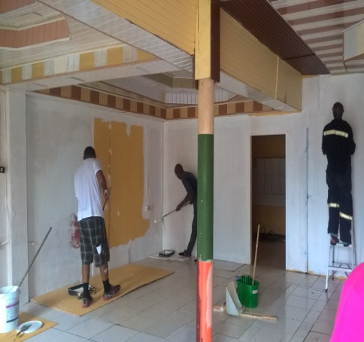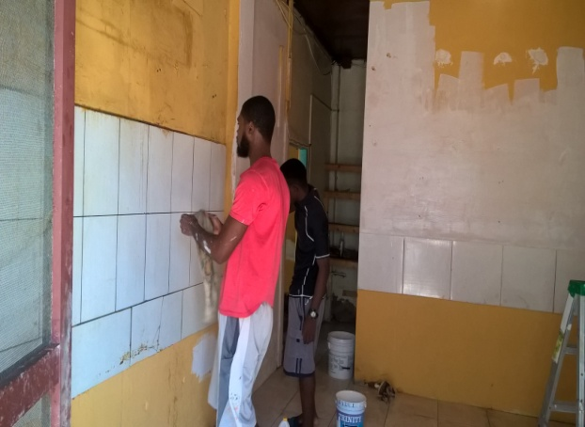
Figure 1 Men assisting
By Sunday, the place was transformed!!
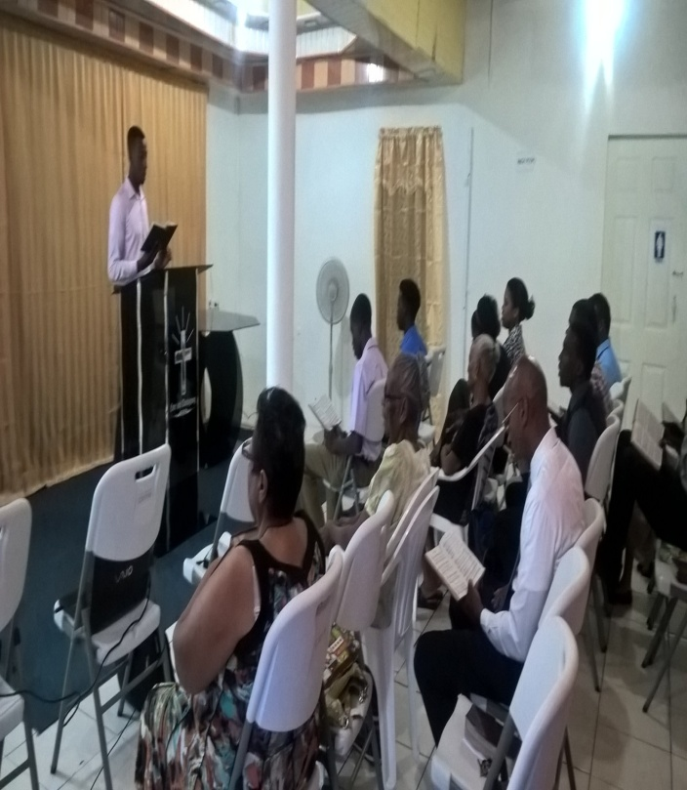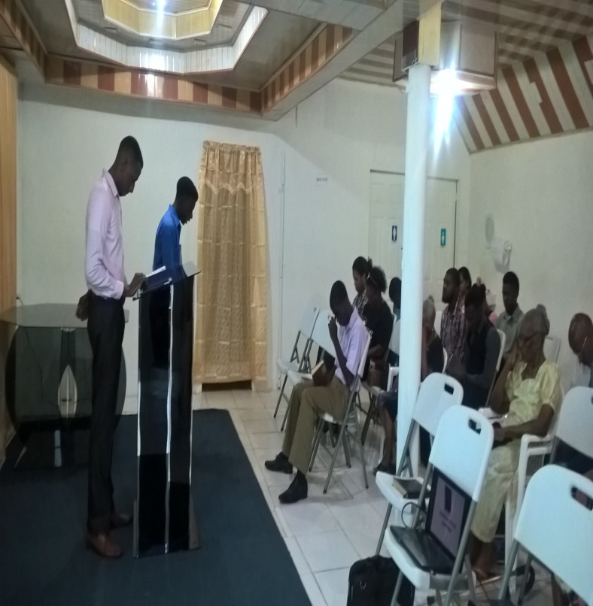
Our full time student body 2017-18
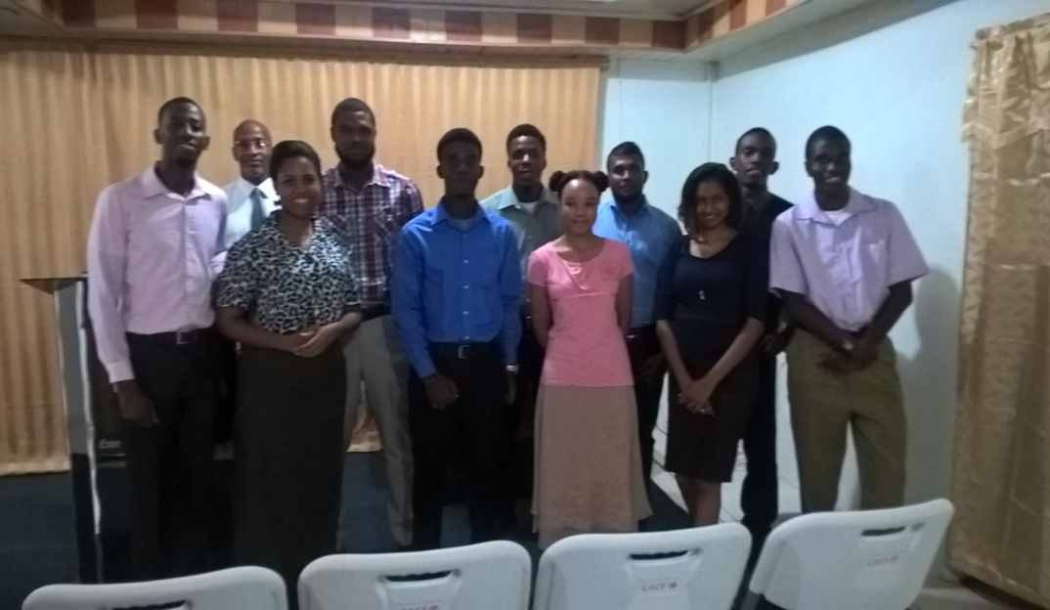
Our link with Bear Valley Bible Institute is proving to be an exciting venture! Thanks to Larry Waymire and especially Keith Kasarjian for their dedication to this work. We now have twenty graduates registered to complete their degrees through leveling courses! This is great for the school as these graduates retool and prepare for growth in their local congregations. This also means by extension that our student body is thirty six!!
Recently, some brethren approached me to consider an evening school where members can be schooled after normal working hours. The school committee is discussing this and has sent out a survey to get more accurate feedback regarding the need of the idea. If the survey indicates a favourable response, we are thinking that the graduates may become teachers thereby using available resources for growth. Please keep this in your prayers.
Finally, we seek your prayers and support for our brethren in Dominica. Hurricane Maria has devastated the island. We are not certain yet what is the best way to help as communication is extremely limited. Thanks again for your kindness and love toward me and my family as we labour in this part of the vineyard.

