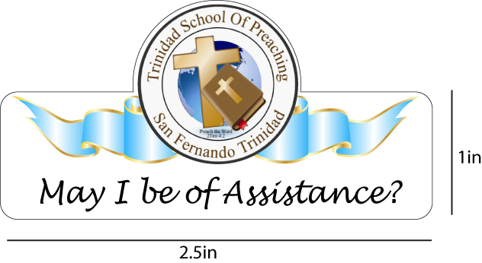
END OF ACADEMIC YEAR REPORT JUNE 2018
What an encouraging year we experienced! Our school is being revitalised in many ways and in particular in reference to evangelism! Our school ventured to take on the task of being involved with congregations in order to help revive the efforts for evangelism. This effort resulted in five active gospel meetings being Fyzabad, Rio Claro, Rancho Quemado, Grenada and Tobago. We also attended in Gasparillo, Felicity and Chaguanas. These all contributed to a renewed spirit for evangelism.
The highlight of this academic year however was our graduation 2018 held on June 3rd. This graduation introduced several firsts and set the pace for the years ahead. Firstly, our 2017 graduation had two students, this year we had four students and eight faculty members.
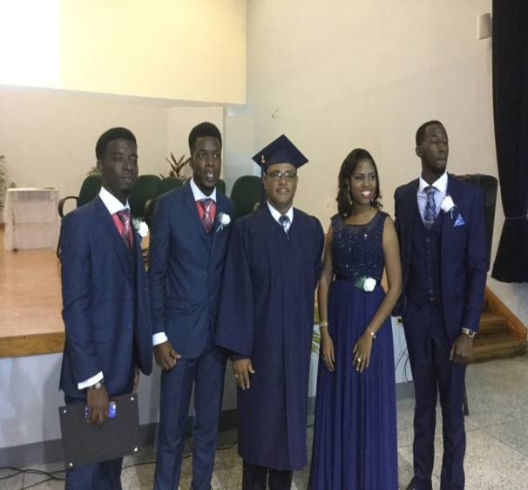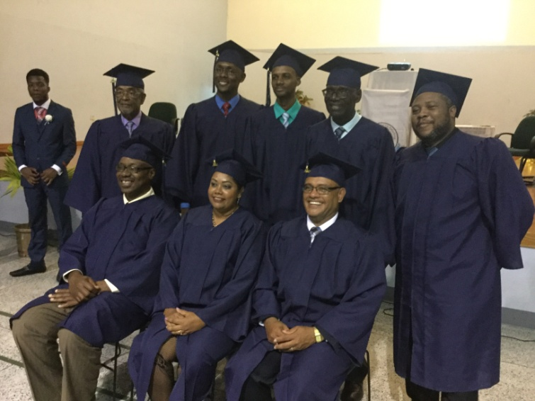
Grads with the Director Faculty members and Director

Another first is that our faculty is the first set of degree recipients in the history of TSOP! This came about as a result of linking with the Bear Valley Bible Institute. Both Keith Kasarjian, the Extension Director and Larry Waymire, the Regional Coordinator for Bear Valley, worked diligently to arrange for our schools to link and offer the degree. For Bear Valley, this was a first in this kind of arrangement. Larry Waymire, in his graduation address noted that Bear Valley was excited by the fact that the TSOP had such a rich history in doctrinal soundness and as such they were just thrilled in the whole idea of the link. Waymire urged the graduands to keep focused on the task and motivated TSOP to move on to Masters with Bear Valley. This is exactly what we had intended and anticipate that all members of faculty will engage the task. Larry presented the degree certificates on the day! While for some this may be a baby step, for us it is a giant jump into an environment we dreamed of years ago.
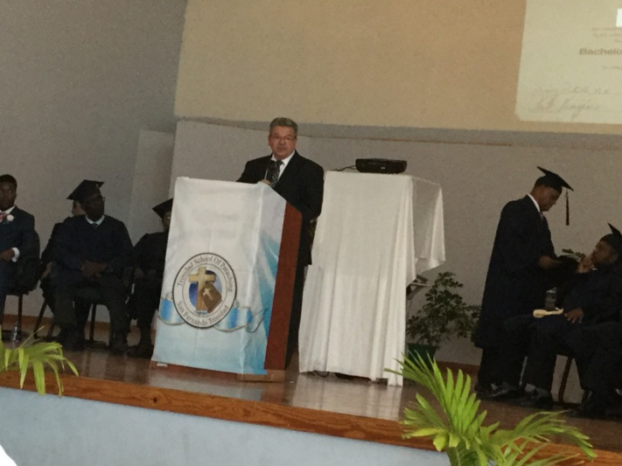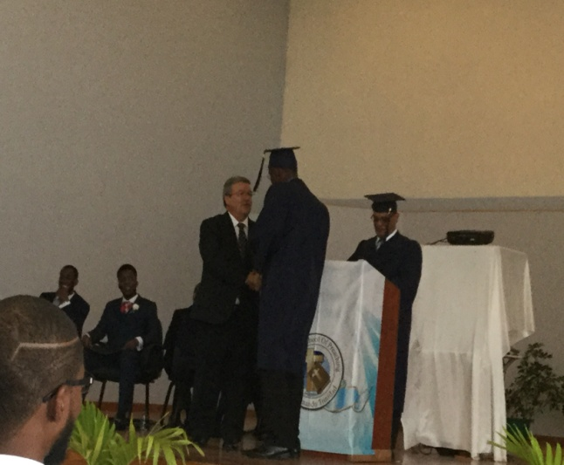
Larry Waymire addressing the grads Larry Presenting degrees
This year, the school committee agreed to include in our graduation, the introduction of an award for Kenneth Mohammed. Brother Mohammed was a member of the very first class of TSOP but never had the opportunity to graduate as he had to return to his profession at that time. The committee felt like he was an appropriate person to be honoured at our graduation exercise. He briefly addressed the gathering and did not hesitate to call all the names of his class and acknowledge them as the real recipients of the honour.
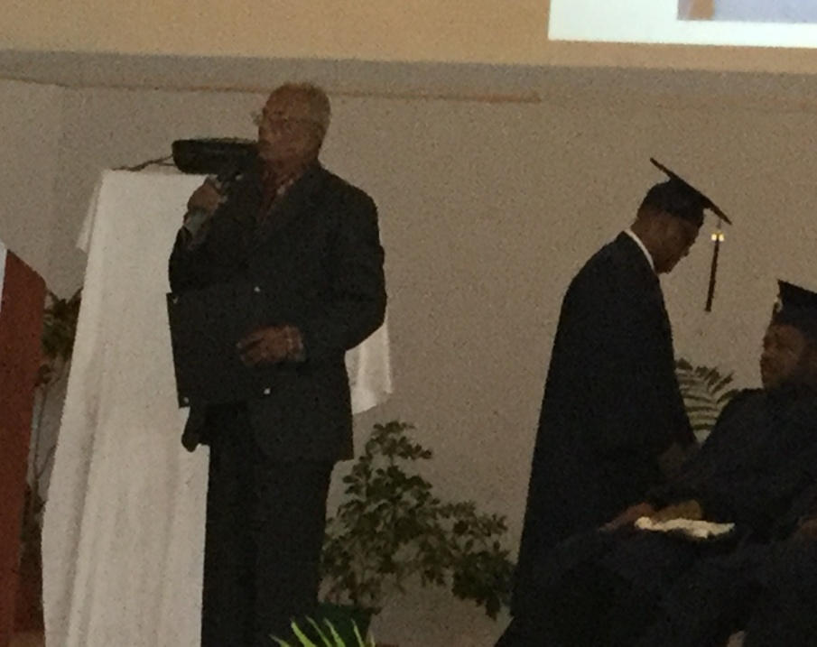
Brother Kenneth Mohammed addressing the gathering
Alongside Kenneth Mohammed, the school selected two recipients of gifts donated by Ann Bell and her daughter Jackie on behalf of the Bell Foundation. The recipients received the solar powered audio player “RENEW”. This gift was presented to two preachers, Sydney Jones and Paul Sandassie. Elders from La Mesa made the presentation on behalf of the Bells.
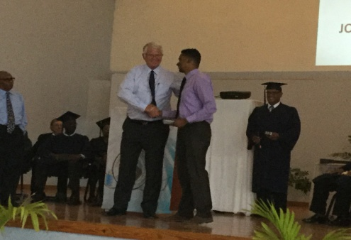Sydney receiving his award from Ronnie. Paul is far left

Mark Hackett was our Featured speaker for the evening and encouraged the graduands to stand for truth in the face of adversity. His message was very timely as all around us; we are being exposed to false doctrine and teachings of men. Mark received a token of our appreciation to the La Mesa church for their many years of support for TSOP.
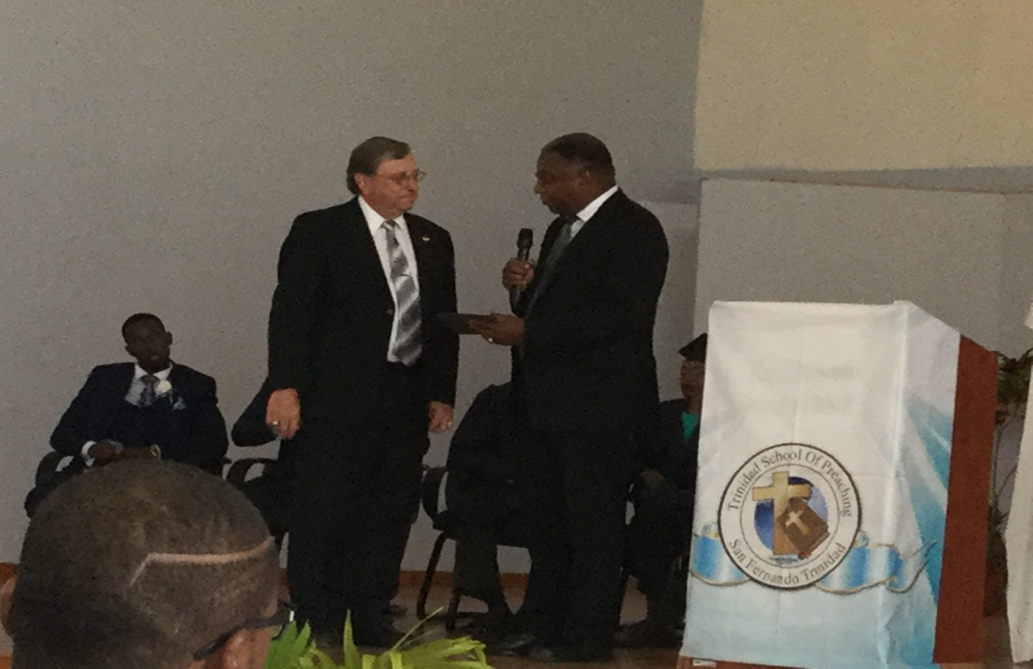
Mark receiving the plaque from Michael Harris, School committee chairman, on behalf of La Mesa
These awards and gifts were all firsts for us at TSOP and were added to the list for the years ahead. The committee acknowledges the fact that as a school we have received over the years and giving back is critical for our growth and development. That being said, a key feature that was another first for TSOP was the introduction of the Parker and Donna Henderson Award. This award, in the names of Parker and Donna Henderson was formally introduced on Graduation day in their honour. The TSOP has been enriched by the labour of these two bulwarks of faith. The award was based on the Passion for the work, the evangelistic spirit and the dedication to the task of soul winning. We believe that Parker and Donna’s legacy could be reflected in this school where they shared over thirty years of their lives teaching and preaching. After consulting Timothy Henderson, who in turn consulted his siblings, and got their approval for its introduction, TSOP decided to honour the Hendersons by presenting an award to a graduate with the same passion, dedication and evangelistic spirit that the Hendersons maintained for all these years. The very first of such an award was presented to Juniour Clarke and Gilbert Neptune, both graduates as well as degree recipients of graduation 2018. The elders from Lamesa presented the awards on behalf of the Hendersons.
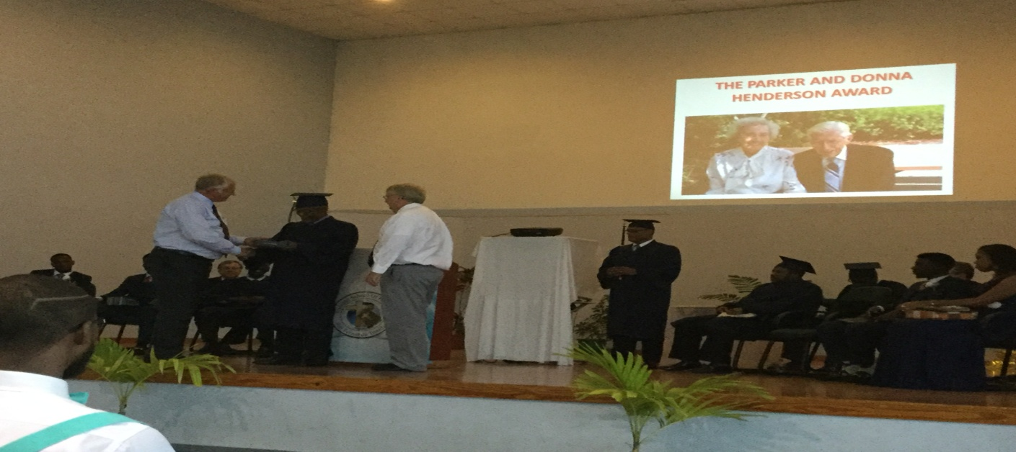’
Our school continues to forge ahead and anticipates seven students in the new semester of September 2018. Alongside these we have nine students in the degree program making a total of eighteen. The period June to August will be utilized to visit congregations around Trinidad and Tobago. Our future student drive has a number of very young males who are already excited about school and hoping to make it part of their educational plans.
Discussions are being held concerning part time classes to facilitate those who are unable to attend regular full time school. This we hope will get on stream soon and allow our school to impact families more directly. Our Saturday school remains focused and our next session may address financial planning and record keeping in congregations. We attempted to address the buggery law issue. Some members who are lawyers have been trying to assist in this session but their schedules conflict at this time. We are hoping to get that done as soon as possible as our nation grapples with the negative impact of changing laws that were landmarks at one time.
God has truly blessed our efforts and we anticipate many more blessings to come as TSOP offers a “higher” education to the church in Trinidad and Tobago as well as the region. Pray for us as we labour together for the cause of Christ. May God continue to open ways for this learning opportunity called TSOP.

Dominic Dos Santos
Director.
June 2018

See below for general pictures from graduation 2018.

THE PROCESSION
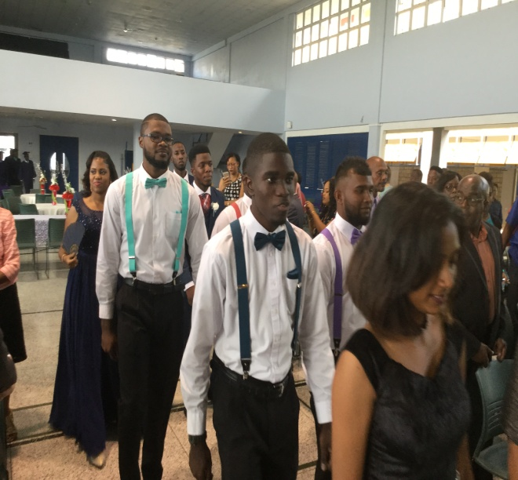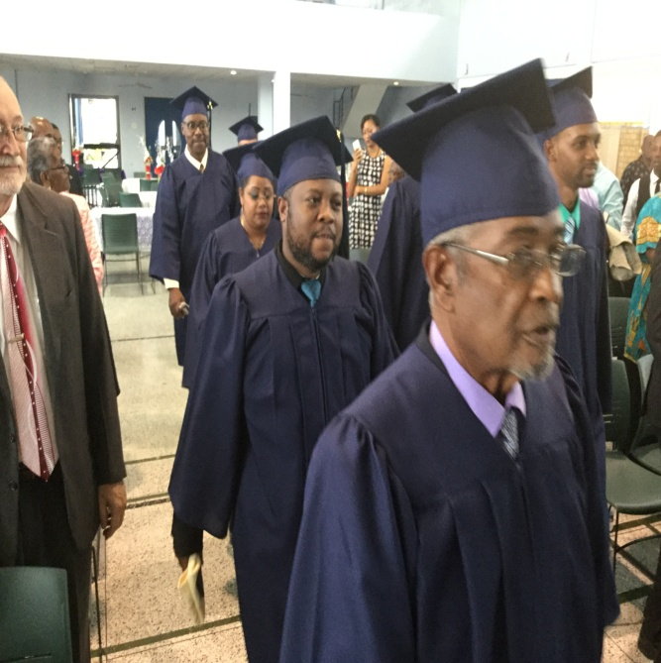
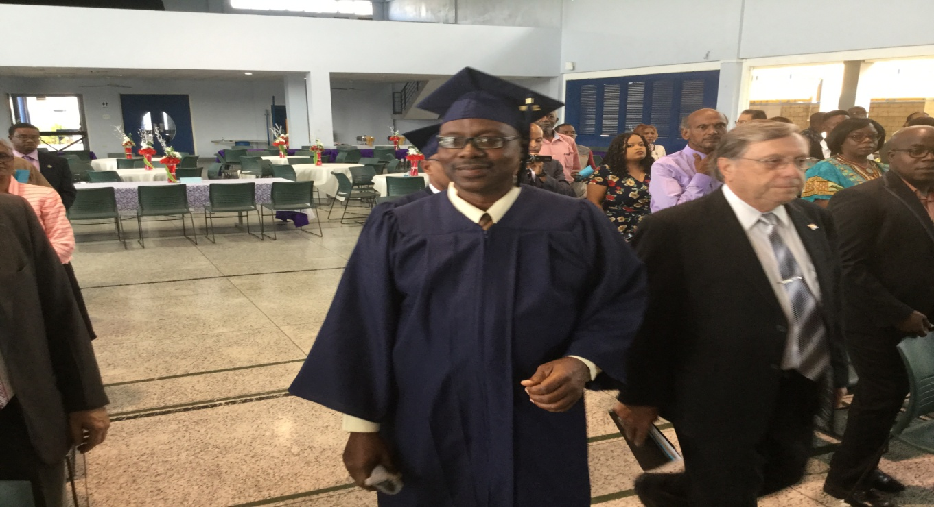

THE STUDENTS ON STAGE
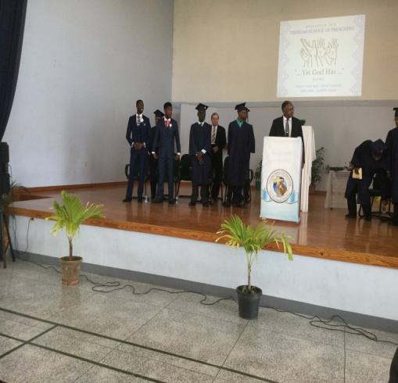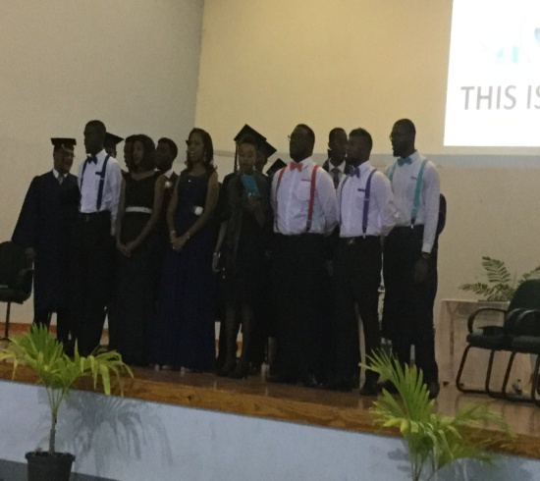

MARK AND MICHAEL PRESENTING CERTIFICATES
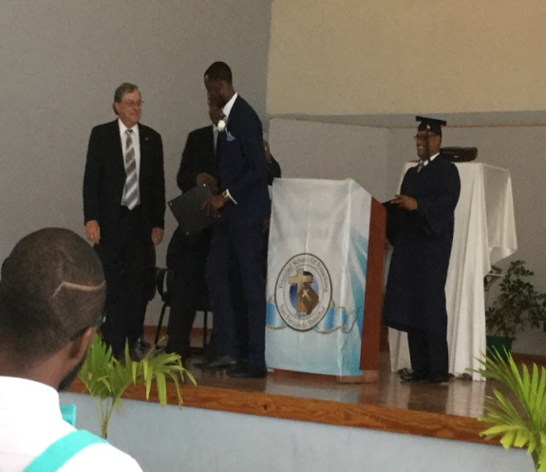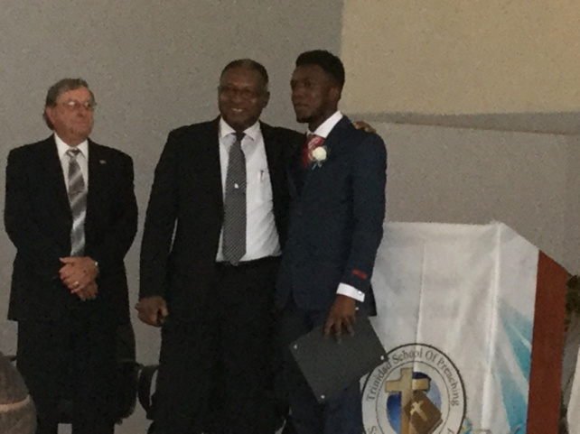

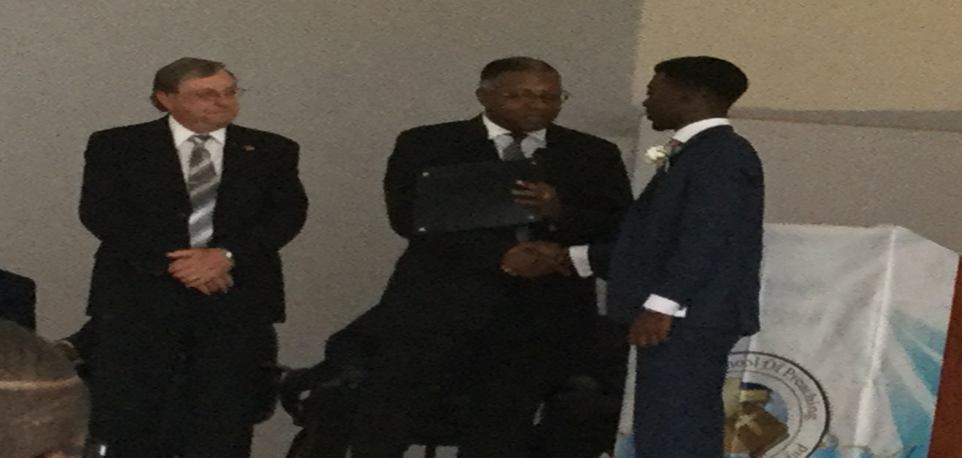

OUR VALEDICTORIAN 2018 CLARISSA CHASE
